**Vs code xtensions :**

C# for visual studio

**Reformatting :**

1. On Windows Shift + Alt + F.

**Vscode extensions:**

C# exteisons - by josh kreativ

auto rename tag – josh hun

bracket pair colorizer -conrasds

material icon theme -phiillip keff

nuget gallery - pcilo

sqlite – alex valzz

postgres sql

API:

**commands:**

dotnet run

dotnet watch run

dotnet tool list -g

**entity framework:**

dotnet tool update --global dotnet-ef --version 6.0.1

dotnet-ef migrations add InitialCreate -o Data/Migrations

dotnet-ef database update

dotnet ef migrations add fixproductDescriptionTypo -context storecontext

dotnet ef database drop

dotnet ef migrations add basketEntityAdded

dotnet ef migrations remove

dotnet ef migrations add OrderEntityAdded -o Data/Migrations

<https://docs.microsoft.com/en-us/ef/core/managing-schemas/migrations/managing?tabs=dotnet-core-cli>

asp core middleware :

<https://docs.microsoft.com/en-us/aspnet/core/fundamentals/middleware/?view=aspnetcore-6.0>

**nugets:**

microsoft.entityframework.sqlite

microsoft.entityframework.core.design

**references:**

<https://www.nuget.org/packages/dotnet-ef/>

dotnet tool install --global dotnet-ef --version 6.0.1

API:

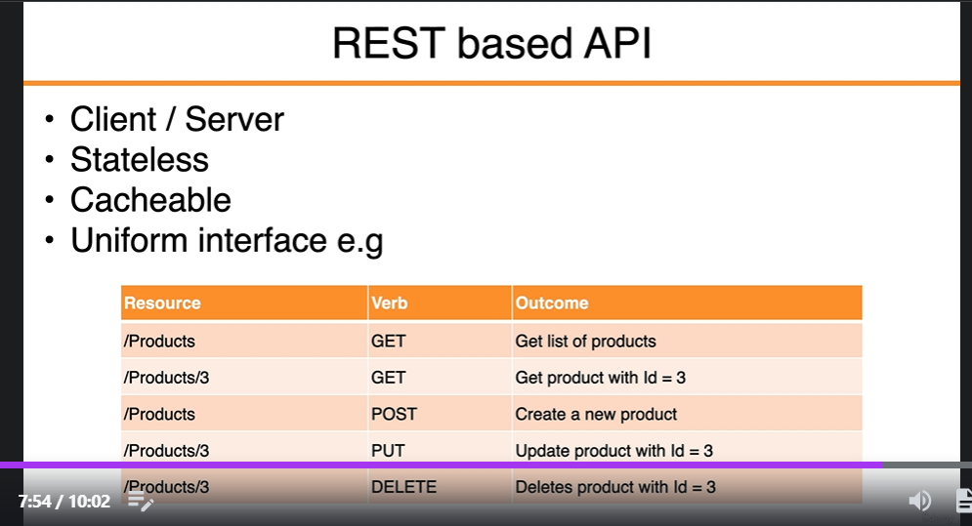

REACT:

webSites:

Reactjs.org

<http://json2ts.com/>

<https://reactjs.org/docs/faq-structure.html> - folder structure -group by features

material ui:

<https://mui.com/> - material UI library

<https://mui.com/getting-started/installation/>

<https://mui.com/customization/typography/>

npm install @mui/material @emotion/react @emotion/styled

npm install @mui/lab

react tostify:

<https://www.npmjs.com/package/react-toastify>

npm install react-toastify

Commands:

New react proj command:

npx create-react-app client –template typescript

run :

cd client - > npm start

installing routing :

npm install [react-router-dom@5.3.0](mailto:react-router-dom@5.3.0)

reactrouter.com API

<https://reactrouter.com/docs/en/v6/api>

reactrouter tester:

<https://v5.reactrouter.com/web/example/auth-workflow>

npm i react-router-dom@5.3.0 @types/react-router-dom@5.3.2

REDUX:

<https://redux.js.org/>

npm install redux react-redux

notes:\

review react tooklit(search for tutorial there)

REDUX :

<https://redux.js.org/style-guide/style-guide/>

REDUX:

<https://redux.js.org/>

npm install redux react-redux

redux toolkit:

<https://redux.js.org/redux-toolkit/overview>

npm install @reduxjs/toolkit

redux thunk:

[GitHub - reduxjs/redux-thunk: Thunk middleware for Redux](https://github.com/reduxjs/redux-thunk)

npm install redux-thunk

chrome extensions :

react devtools

redux devtools

TOKEN DECIPHER SITE :

<https://jwt.io/>

{

"username": "bob",

"password": "Pa$$w0rd"

}

Regular expression site:

<https://regexlib.com/?AspxAutoDetectCookieSupport=1>

yup validations :

npm install @hookform/resolvers yup

React hook form :

<https://react-hook-form.com/>

npm install react-hook-form

<https://react-hook-form.com/api/usecontroller>

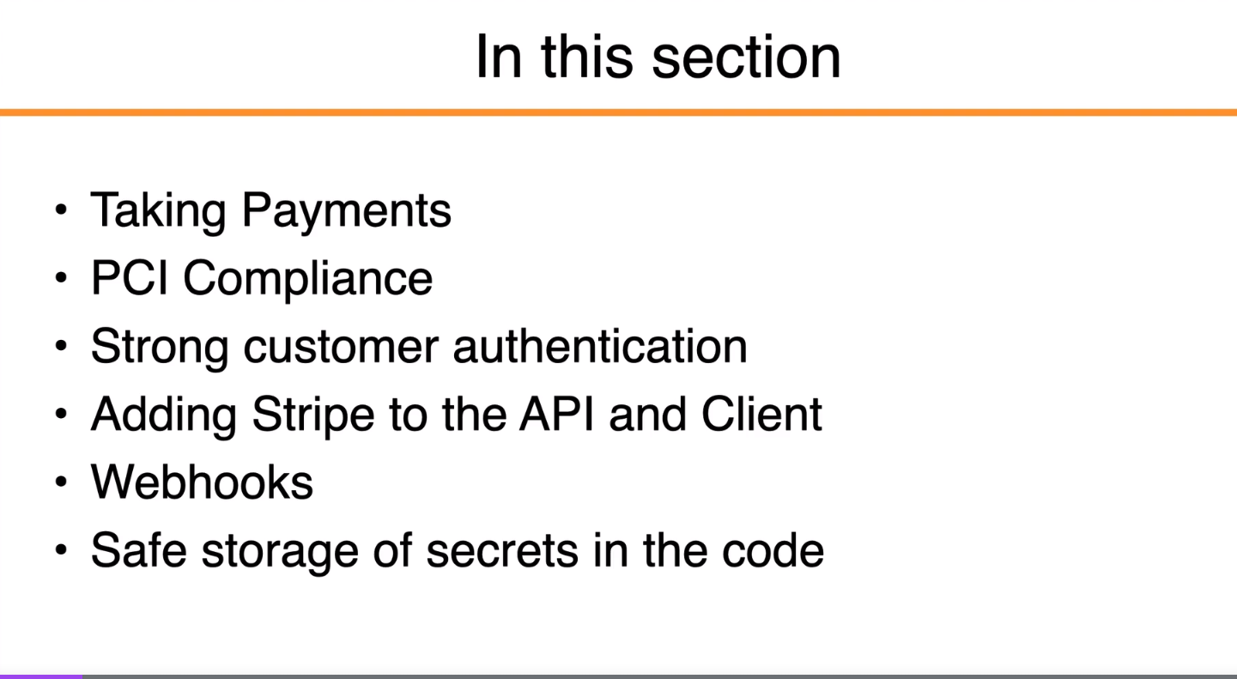

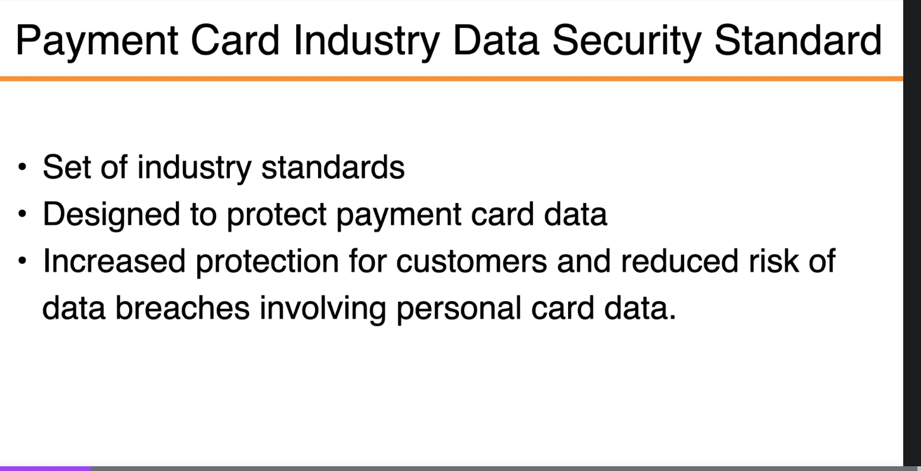

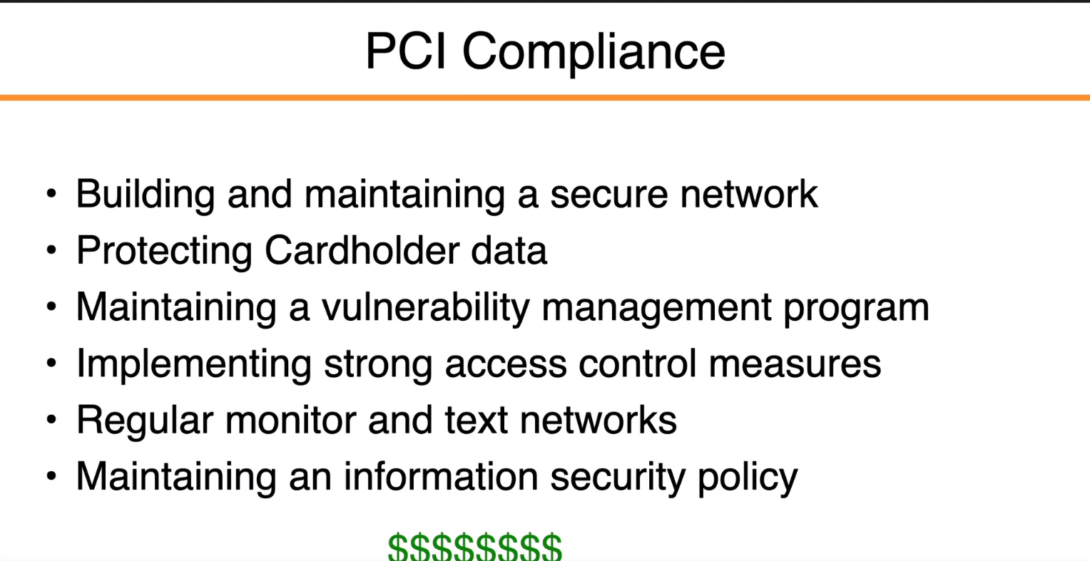

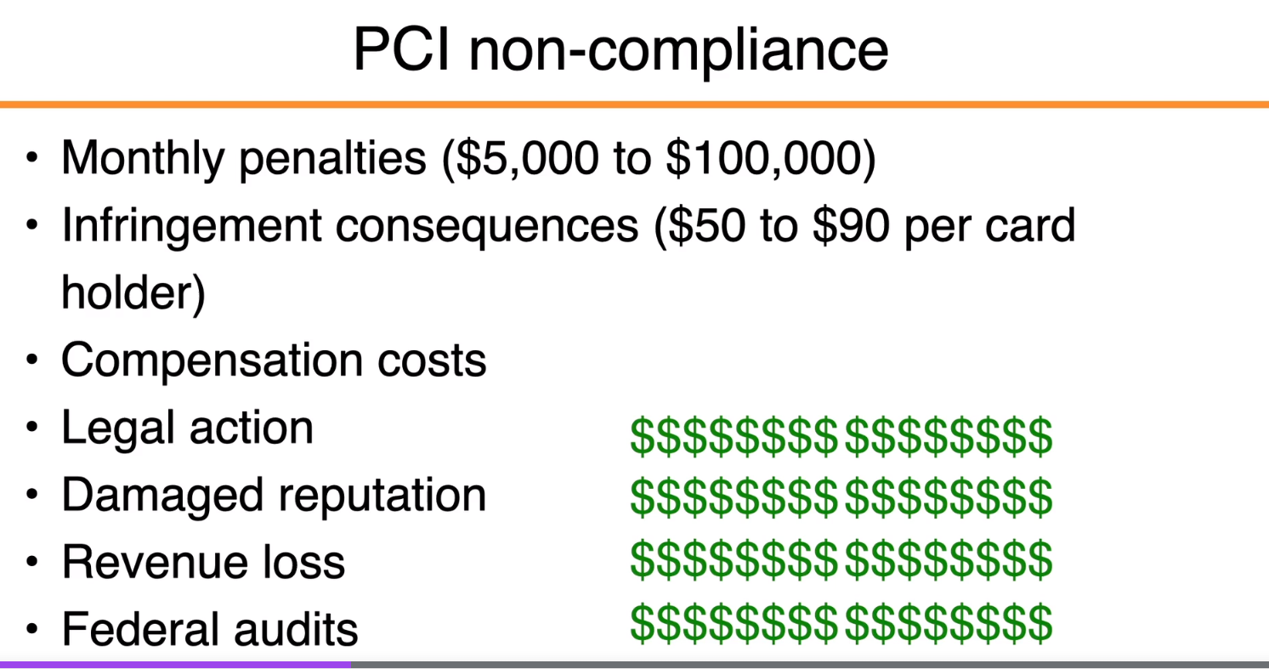

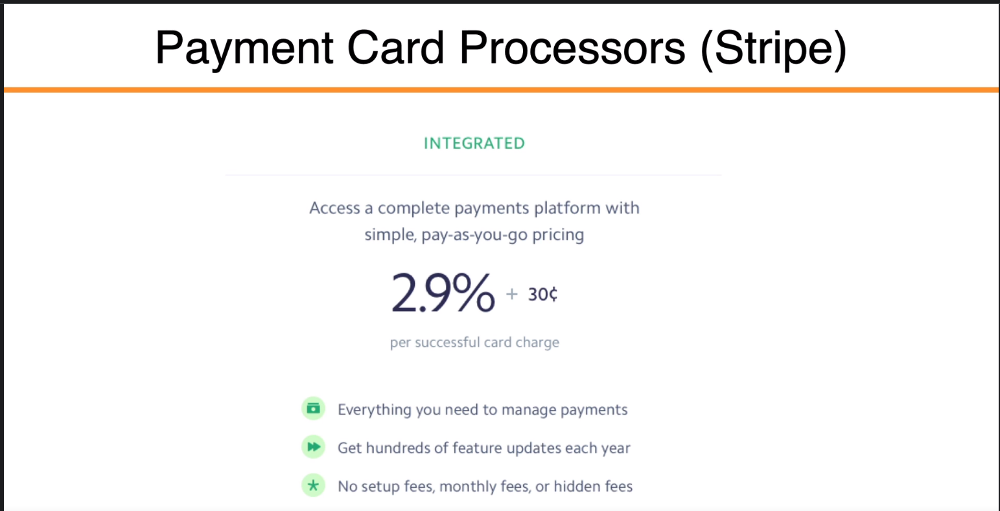

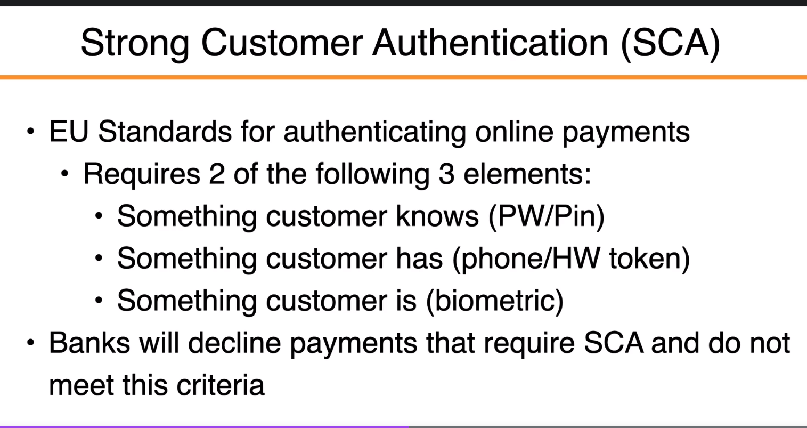

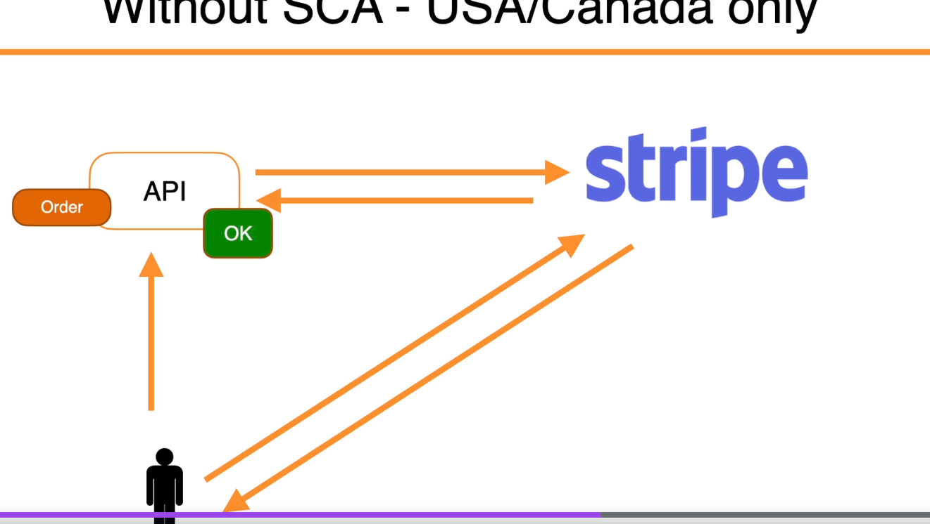

[**https://stripe.com/**](https://stripe.com/)

[**https://stripe.com/docs/stripe-js/react**](https://stripe.com/docs/stripe-js/react)

[**https://stripe.com/docs/testing**](https://stripe.com/docs/testing)

**npm install --save @stripe/react-stripe-js @stripe/stripe-js**

**imperative handle:**

[**https://reactjs.org/docs/hooks-reference.html#useimperativehandle**](https://reactjs.org/docs/hooks-reference.html#useimperativehandle)

**webhooks :**

**.\stripe listen -f http://localhost:5003/api/payments/webhook -e charge.succeeded**

DoTNET SECRET MANAGER:

<https://docs.microsoft.com/en-us/aspnet/core/security/app-secrets?view=aspnetcore-6.0&tabs=windows>

dotnet user-secrets init

dotnet user-secrets set "StripeSettings:PublishableKey" "pk_test_51HIv6eDRd0LwUKYJuG37UvfhAkLPaYAp2h2wJilEn66FfwzrXCWvojIUYeZ7gYZwVaZgLSPrOmL4YHlexcXc09ud00rhTlHFqT"

C:\Users\MosheG\AppData\Roaming\Microsoft\UserSecrets

React carousel:

<https://react-slick.neostack.com/>

npm install react-slick @types/react-slick slick-carousel

react customable environment variables:

<https://create-react-app.dev/docs/adding-custom-environment-variables/>

<https://create-react-app.dev/docs/adding-custom-environment-variables/#adding-development-environment-variables-in-env>

run in production mode:

npm run build

cloud image service:

<https://cloudinary.com/>

Assigned Cloud Name: **webtargetcloud**

React dropzone :

<https://react-dropzone.js.org/>

<https://github.com/react-dropzone/react-dropzone>

npm install --save react-dropzone

Microsoft database providers:

<https://docs.microsoft.com/en-us/ef/core/providers/?tabs=dotnet-core-cli>

production db - docker:

<https://www.docker.com/products/docker-desktop>

docker run --name dev -e POSTGRES_USER=appuser -e POSTGRES_PASSWORD=secret -p 5432:5432 -d postgres:latest

Heroku:

Install the Heroku cli:

<https://devcenter.heroku.com/articles/heroku-cli#install-the-heroku-cli>

heroku login

heroku git:remote -a webtarget-restore-course

Heroku buildpacks:

<https://elements.heroku.com/buildpacks>

<https://elements.heroku.com/buildpacks/jincod/dotnetcore-buildpack>

dotnet stable :

heroku buildpacks:set jincod/dotnetcore

PUSHING TO HEROKU:

git push heroku main